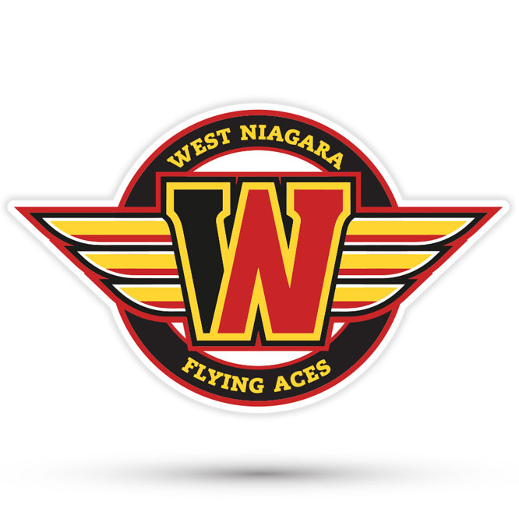
West Niagara Flying Aces Minor Hockey
Association Inc.
Coach Selection Process
2026 / 2027 Season

WNMHA Coach Selection Process

Policy Statement
The West Niagara Minor Hockey Association (WNMHA) Coaches Selection Committee is committed to identifying and appointing individuals who exemplify the highest standards of coaching excellence, as detailed in this policy. The Committee pledges to ensure that the selection process is conducted with fairness, transparency, and consistency, upholding the integrity and values of the Association at every stage.

Selection Criteria
The Committee’s foremost objective is to appoint the most suitable candidate for each coaching role, recognizing that the “Best Fit” and “Most Qualified” applicants may not always be synonymous. The ideal candidate is one who effectively demonstrates both sets of attributes, thereby best serving the needs of WNMHA teams and athletes.

Evaluation Criteria
- Certification and Training: Applicants must hold, or be prepared to obtain, the minimum National Coach Certification Program (NCCP) qualification appropriate to the age group for which they are applying, as mandated by the Ontario Hockey Federation (OHF), Ontario Minor Hockey Association (OMHA), and Hockey Canada. Candidates must also complete a police background check and satisfy all other compliance requirements as stipulated by relevant governing bodies.
- Coaching Experience: Applicants are required to provide a comprehensive summary of their coaching background, including:
  - Tenure as Head Coach and Assistant Coach, specified in years or seasons
  - Details of divisions, levels, and associations or organizations previously coached
  - Age groups and skill levels of former teams, including duration with each team
  - Relevant experience in coaching other organized sports, which will be considered in the absence of, or in addition to, hockey coaching experience
  - Demonstrated history of positive team development and measurable success in prior coaching roles
  - Personal hockey playing experience
  - Completion of supplementary hockey training or professional development courses
  - Additional relevant experience, such as officiating, volunteering, or fulfilling other minor hockey responsibilities
- Coaching Philosophy and Approach: Applicants must articulate their coaching philosophy as it relates to minor hockey, ensuring alignment with WNMHA’s core values. The following elements should be addressed:
  - Methodology for player evaluation and team selection
  - Criteria and process for selecting and managing assistant coaches and bench staff
  - Commitment to adhering to all WNMHA policies and procedures
  - Preparation and planning for practices and games
  - Standards of conduct on the bench and in dressing rooms
  - Promotion of fair play and constructive interactions with officials
  - Player development strategies and philosophies
  - Approach to in-game decision making
  - Demonstrated interpersonal and communication skills
  - Problem-solving capabilities
  - Ability to teach, motivate, and foster positive relationships with players
  - Leadership qualities, attitude, and rapport with parents
- Interview: Selected candidates may be invited to participate in a formal interview, during which all the criteria may be discussed in detail. Failure to attend a scheduled interview, if requested, will result in immediate disqualification from the selection process.

Term and Reapplication
Coaching appointments are valid for a single season. All interested parties, including incumbent coaches, must reapply for consideration each season. While returning coaches may, in certain circumstances, be given preference, reappointment is not automatic and is contingent upon the outcome of the selection process.

Selection Committee
WNMHA will appoint a Coaching Selection Committee, chaired by the Skills/Coach Development Coordinator. The committee shall include at least three board members, with additional or substitute members appointed at the Board’s discretion as needed.
Conflicts of Interest
If a member of the Coaching Selection Committee or the Board applies for a coaching position or has a familial relationship with a candidate, they must declare a conflict of interest and recuse themselves from all aspects of the selection process concerning that role. A substitute committee member will be chosen from an approved list of alternates.
Application Process
Applicants must submit a separate coaching application for each team for which they are seeking a position. Application forms will be available online through the WNMHA website. Completed applications, including reference contact information, should be submitted to the WNMHA Development Director in the manner specified on the website. Each application must clearly indicate the age group and category (AA, A, BB) being applied for. Applications will only be accepted during the application period indicated on the WNMHA website.
Upon receipt of all applications, the committee shall:
- Review each application against the established selection criteria,
- Evaluate any available coach assessments provided by convenors,
- Contact one or both references listed by the applicant, as deemed necessary,
- Reach out to any other individuals or organizations who, in the committee’s sole discretion, may provide relevant information regarding the applicant,
- Conduct interviews as determined necessary by the committee.

Following the evaluation process, the Coaches Selection Committee will develop a shortlist of coaching candidates to present for voting. While unanimity is preferred, approval by a simple majority of the Committee will be sufficient in cases of disagreement.
Should the Coaches Selection Committee determine that none of the initial applicants for a particular age group meet the required standards, the Committee has no obligation to appoint a coach for that group and may choose to reopen applications or actively seek out qualified individuals. In this scenario, the position will remain vacant until an appropriate candidate is identified. A member of the Coaches Selection Committee may serve as interim coach or appoint a temporary replacement until a permanent selection is made.
The Committee will submit the list of selected head coach applicants to the WNMHA board during a regularly scheduled meeting or a special meeting convened for this purpose. During this meeting, the board and Committee will also identify any teams without an appointed head coach and may provide recommendations to the Committee regarding potential individuals for recruitment.
Following the Coach Selection meeting, the Development Director will promptly notify successful applicants via email or phone call and confirm their acceptance of the position.
Once all appointments have been confirmed, the Development Director will inform the WNMHA board of any teams still requiring coaches. For these teams, the Development Director, in collaboration with convenors, will seek suitable candidates, request completion of an application, and review submissions for consideration and approval.

COACHES CONTRACT
Should my application be accepted and approved by West Niagara Minor Hockey:
A) I agree to fulfill all responsibilities as a coach in alignment with the expectations set forth by WNMHA and its members. I will promote sportsmanship and fair play among all players and consistently act as an exemplary role model.
B) I hereby commit to adhering to the By-Laws, Rules of Operation, guidelines, and philosophies established by WNMHA, including those set by its Development Coordinator, conveners, and committees. Non-compliance may result in termination or other disciplinary actions as determined by the Executive.
C) I acknowledge and accept that the Head Coach bears ultimate responsibility for the conduct and performance of all team staff. Furthermore, all signatories are subject to discipline or suspension at the discretion of WNMHA.
D) I understand that as a coach, I must possess the certifications required by the Ontario Minor Hockey Association and will ensure my team staff meet these standards.
E) I am aware that failure to adhere to OMHA and, specifically, WNMHA rules and regulations will result in immediate dismissal.
F) As a condition of selection, I agree to submit to a Vulnerable Sector Police Check and comply with the requirements outlined in the WNMHA Policy on Volunteer Screening.
---
Assistant Coaches and Bench Staff
The selection of bench staff is the responsibility of the appointed head coach for each team; WNMHA does not appoint or select bench staff directly. Applicants deemed unacceptable by the Selection Committee as head coaches are ineligible for appointment as assistant coaches by any successful head coach. This distinction does not preclude a named head coach from considering candidates who were simply not selected as head coach for bench roles. Being “not acceptable” differs from being “not successful.”
Before submitting team rosters to the OMHA, each team must present its proposed coaching staff to the Development Director. The Development Director, in consultation with the WNMHA Board, reserves the right to veto any proposed coaching staff appointments based on prior conduct or imposed sanctions.

2026-27 Proposed Timeline

Advertise on the website/Applications Open Jan 3rd, 2026
Applications Close Jan 20th, 2026
Interview perspective coaches U10-U18
Announce AA coaches
Announce A coaches
Announce BB coaches
Interview perspective coaches U8MD, U9MD
Announce MD coaches
Announce LL coaches

