Updating Your Spordle Account (old Hockey Canada)

In browser go to: https://account.spordle.com/login
Enter your email address then LOGIN, enter password
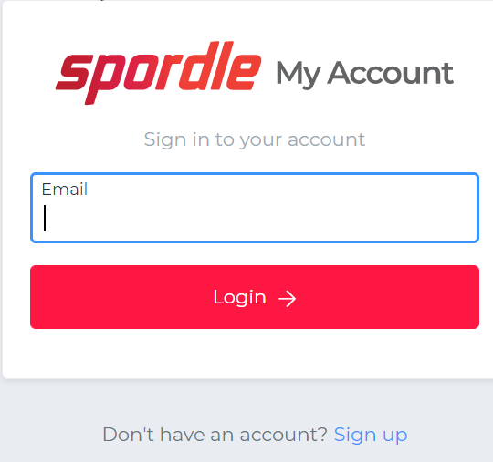

Landing page:
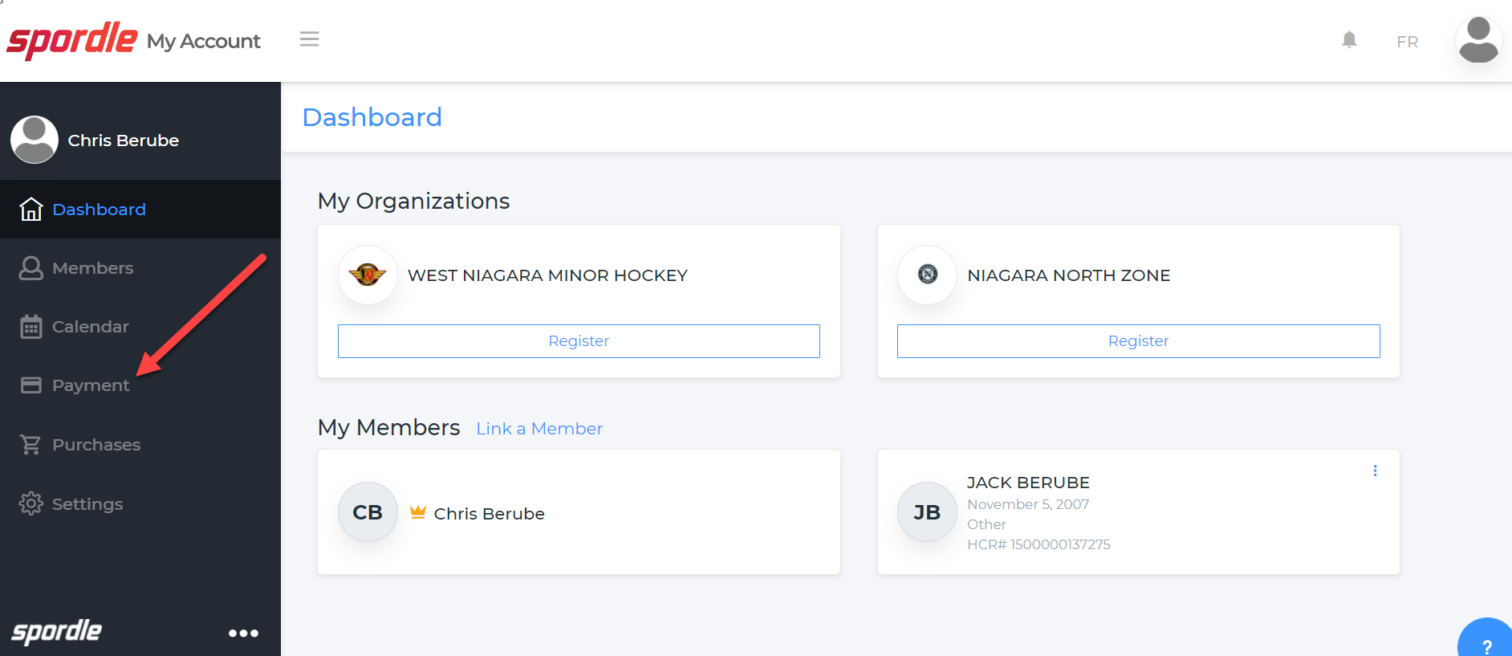

To update your Credit Card information click on Payments

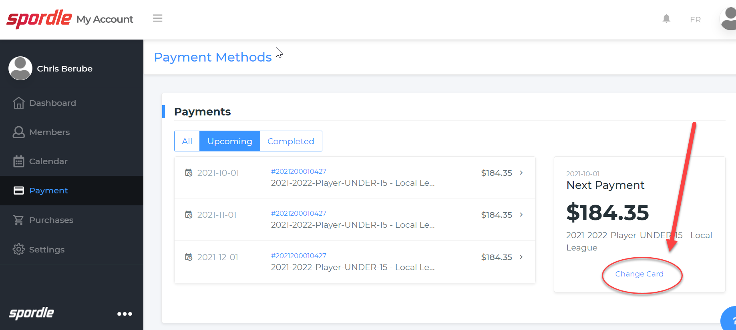

Click on CHANGE CARD
An instruction window will open click accordingly and follow the prompt
